Title
A.F. Ivanov¹,I.I. Petrov^{1*}, S.V. Sidorov², A.A. Kuznetsov¹
¹Moscow State University, Department of Chemistry
²Institute of Synthetic Polymer Materials RAS
*e-mail: petrov@mail.net
Document format: Microsof Word (*.doc) or Rich Text Format (*.rtf).
All margins: 2,5 cm. Font: Times New Roman with single line spacing.
Title: bold 12 pt, alignment – center. Indent 12 pt.
Authors’ names: italic 12 pt, alignment – center, name of the speaker should be underlined. Indent 6 pt.
Organization(s) (only names of the organizations without their addresses) and e-mail: normal 12 pt, alignment – center. Indent 12 pt.
Text: 1 full page, normal 12 pt, alignment – justified, no paragraph indent.
References: normal 12 pt, name of the journal should be italic, volume - bold.
Figures should be inserted in line with text.
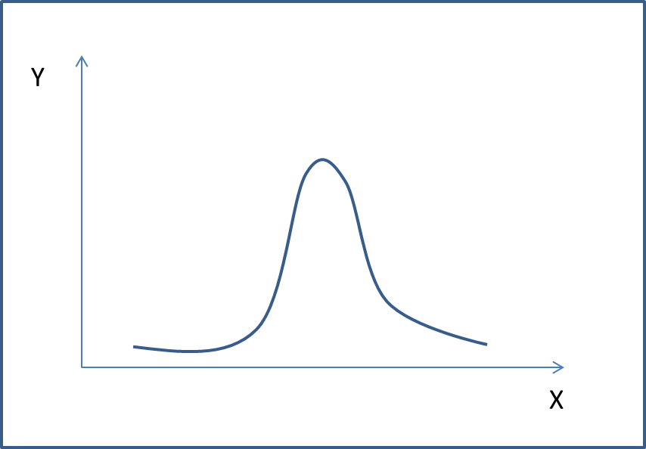
Fig. 1. Figure title
Figure title: below figures, normal 12 pt, alignment – center. Indent 6 pt.
Gratitude for financial support should be below body text, italic 12 pt.
Lorem Ipsum is simply dummy text of the printing and typesetting industry. Lorem Ipsum has been the industry's standard dummy text ever since the 1500s, when an unknown printer took a galley of type and scrambled it to make a type specimen book. It has survived not only five centuries, but also the leap into electronic typesetting, remaining essentially unchanged. It was popularised in the 1960s with the release of Letraset sheets containing Lorem Ipsum passages, and more recently with desktop publishing software like Aldus PageMaker including versions of Lorem Ipsum.
This work was supported by RFBR (project № 00-00-00000).

Ivanov I.I., Zuzin R.V. Organomet.Chem. 2003, 21(1), 144-150.

